

CSA0501-DATABASE MANAGEMENT SYSTEMS

LAB EXPERIMENTS DATE: 14/07/2026

EXPERIMENT 5 -- SELECT with various clause – WHERE, pattern matching

AIM:

To retrieve and display records from the Student_CGPA table using the SELECT statement with WHERE clause and LIKE operator for filtering data based on conditions and pattern matching in MySQL Workbench.

PROCEDURE:
- Open MySQL Workbench and connect to the MySQL server.
- Create a new database and select it using the USE command.
- Create the student_cgpa table with the required columns and constraints.
- Insert sample records into the student_cgpa table using the INSERT statement.
- Execute SELECT statements to display data from the table.
- Use the WHERE clause to retrieve records based on specific conditions such as department, city, CGPA, and number of failed subjects.
- Use the LIKE operator with wildcard characters (% and _) to perform pattern matching on student names and city names.
- Execute each query in MySQL Workbench and verify the output displayed in the Result Grid.
- Analyze the retrieved records to understand how the WHERE clause and LIKE operator filter data.
- Conclude the experiment after successfully obtaining the required outputs.

PROGRAM:

1. CREATE TABLE

CREATE TABLE student_cgpa (
reg_no VARCHAR(15) PRIMARY KEY,
student_name VARCHAR(50) NOT NULL,
department VARCHAR(20),
no_of_subs_pass INT,
no_of_subs_fail INT,
cgpa DECIMAL(3,2)
);
Then Insert Values:
INSERT INTO student_cgpa
(reg_no, student_name, department, no_of_subs_pass, no_of_subs_fail, cgpa)
VALUES
('192411123','Deepthi','CSE',22,2,8.71),
('192512121','Varun','IT',27,1,9.23),
('192312117','Aadhya','ECE',25,3,8.97),
('192411227','Dimple','CSE',31,0,9.37),
('192820896','Mohan','EEE',18,9,6.48),
('192411122','Yogitha','CSE',31,1,9.01),
( '192516871','Sadhya','IT',25,5,7.22),
('192111101','Rahul','MECH',30,12,5.14),
('192411010','Alekhya','CSE',35,2,9.01),
('192511135','Rahul','CIVIL',37,0,9.72);

SELECT * FROM student_cgpa;

OUTPUT:

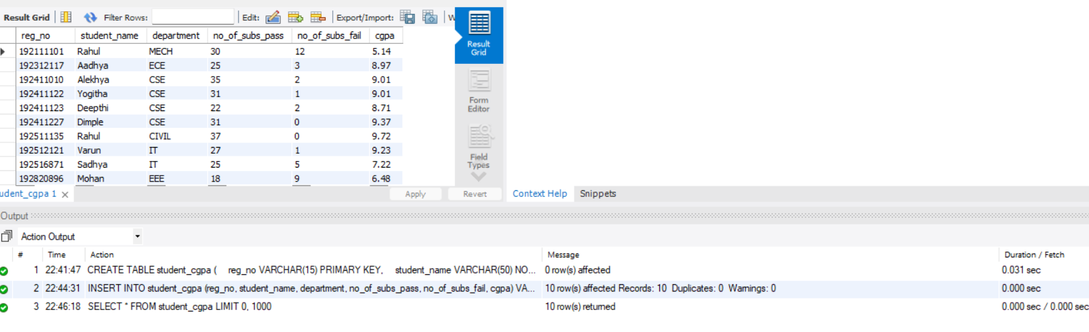

WHERE Clause

1. Display Registration Number, Student Name and CGPA of all students.

SELECT reg_no, student_name, cgpa

FROM student_cgpa;

OUTPUT:

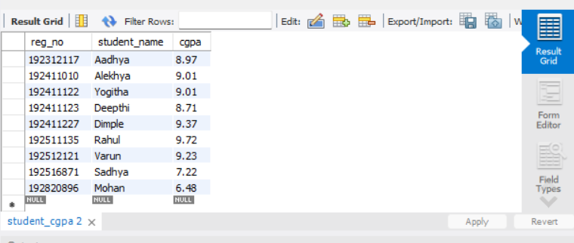

2. Display all students from the CSE department.

SELECT *
FROM student_cgpa
WHERE department = 'CSE';

OUTPUT:
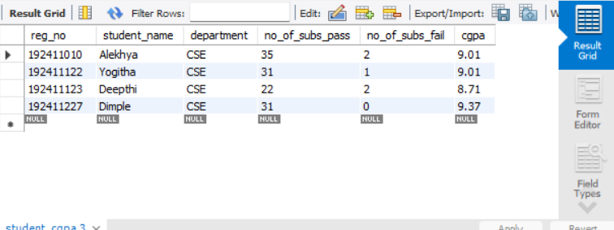

3. Display students whose CGPA is greater than 9.00.

SELECT *
FROM student_cgpa
WHERE cgpa > 9.00;

OUTPUT:

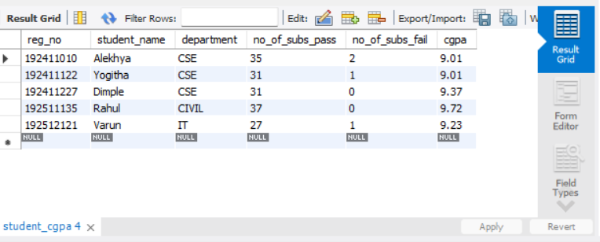

4. Display students who have failed in one or more subjects.

SELECT *
FROM student_cgpa
WHERE no_of_subs_fail > 0;

OUTPUT:

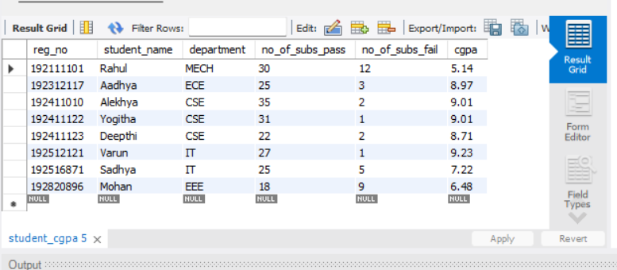

5. Display students who have passed more than 30 subjects.

SELECT *
FROM student_cgpa
WHERE no_of_subs_pass > 30;

OUTPUT:

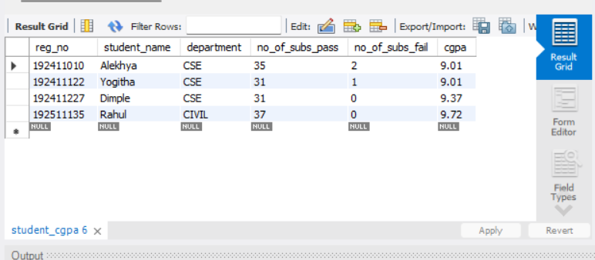

LIKE Clause

6. Display students whose names end with "sh".

SELECT *
FROM student_cgpa
WHERE student_name LIKE '%sh';

OUTPUT:

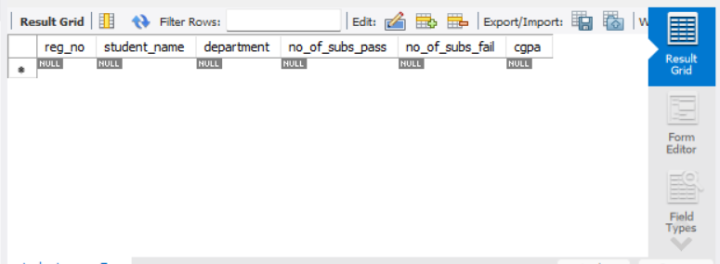

7. Display students whose names contain "sh".

SELECT *
FROM student_cgpa
WHERE student_name LIKE '%sh%';

OUTPUT:

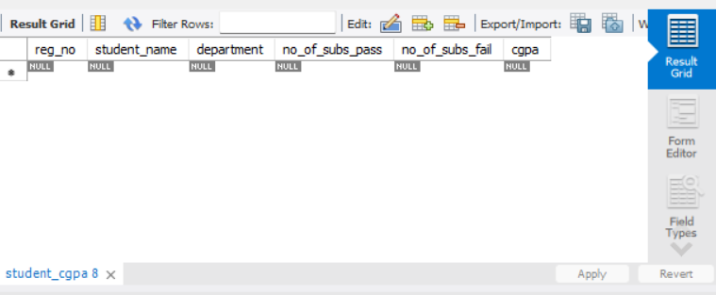

8. Display students whose department contains "CS".

SELECT *
FROM student_cgpa
WHERE department LIKE '%CS%';

OUTPUT:

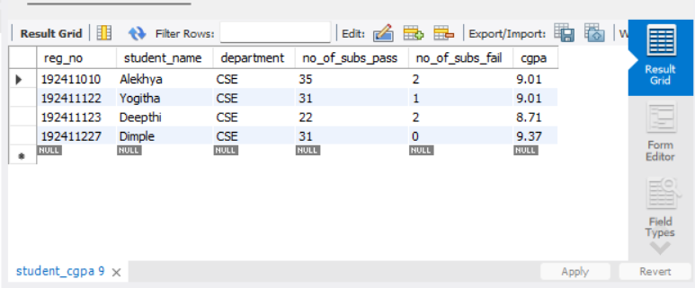

9. Display students whose names do not contain six letters.

SELECT *
FROM student_cgpa
WHERE student_name NOT LIKE '______';

OUTPUT:

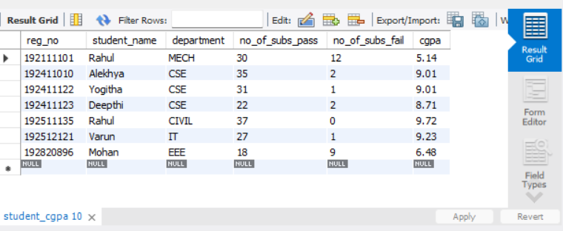

10. Display students whose names contain "am".

SELECT *
FROM student_cgpa
WHERE student_name LIKE '%am%';

OUTPUT:
